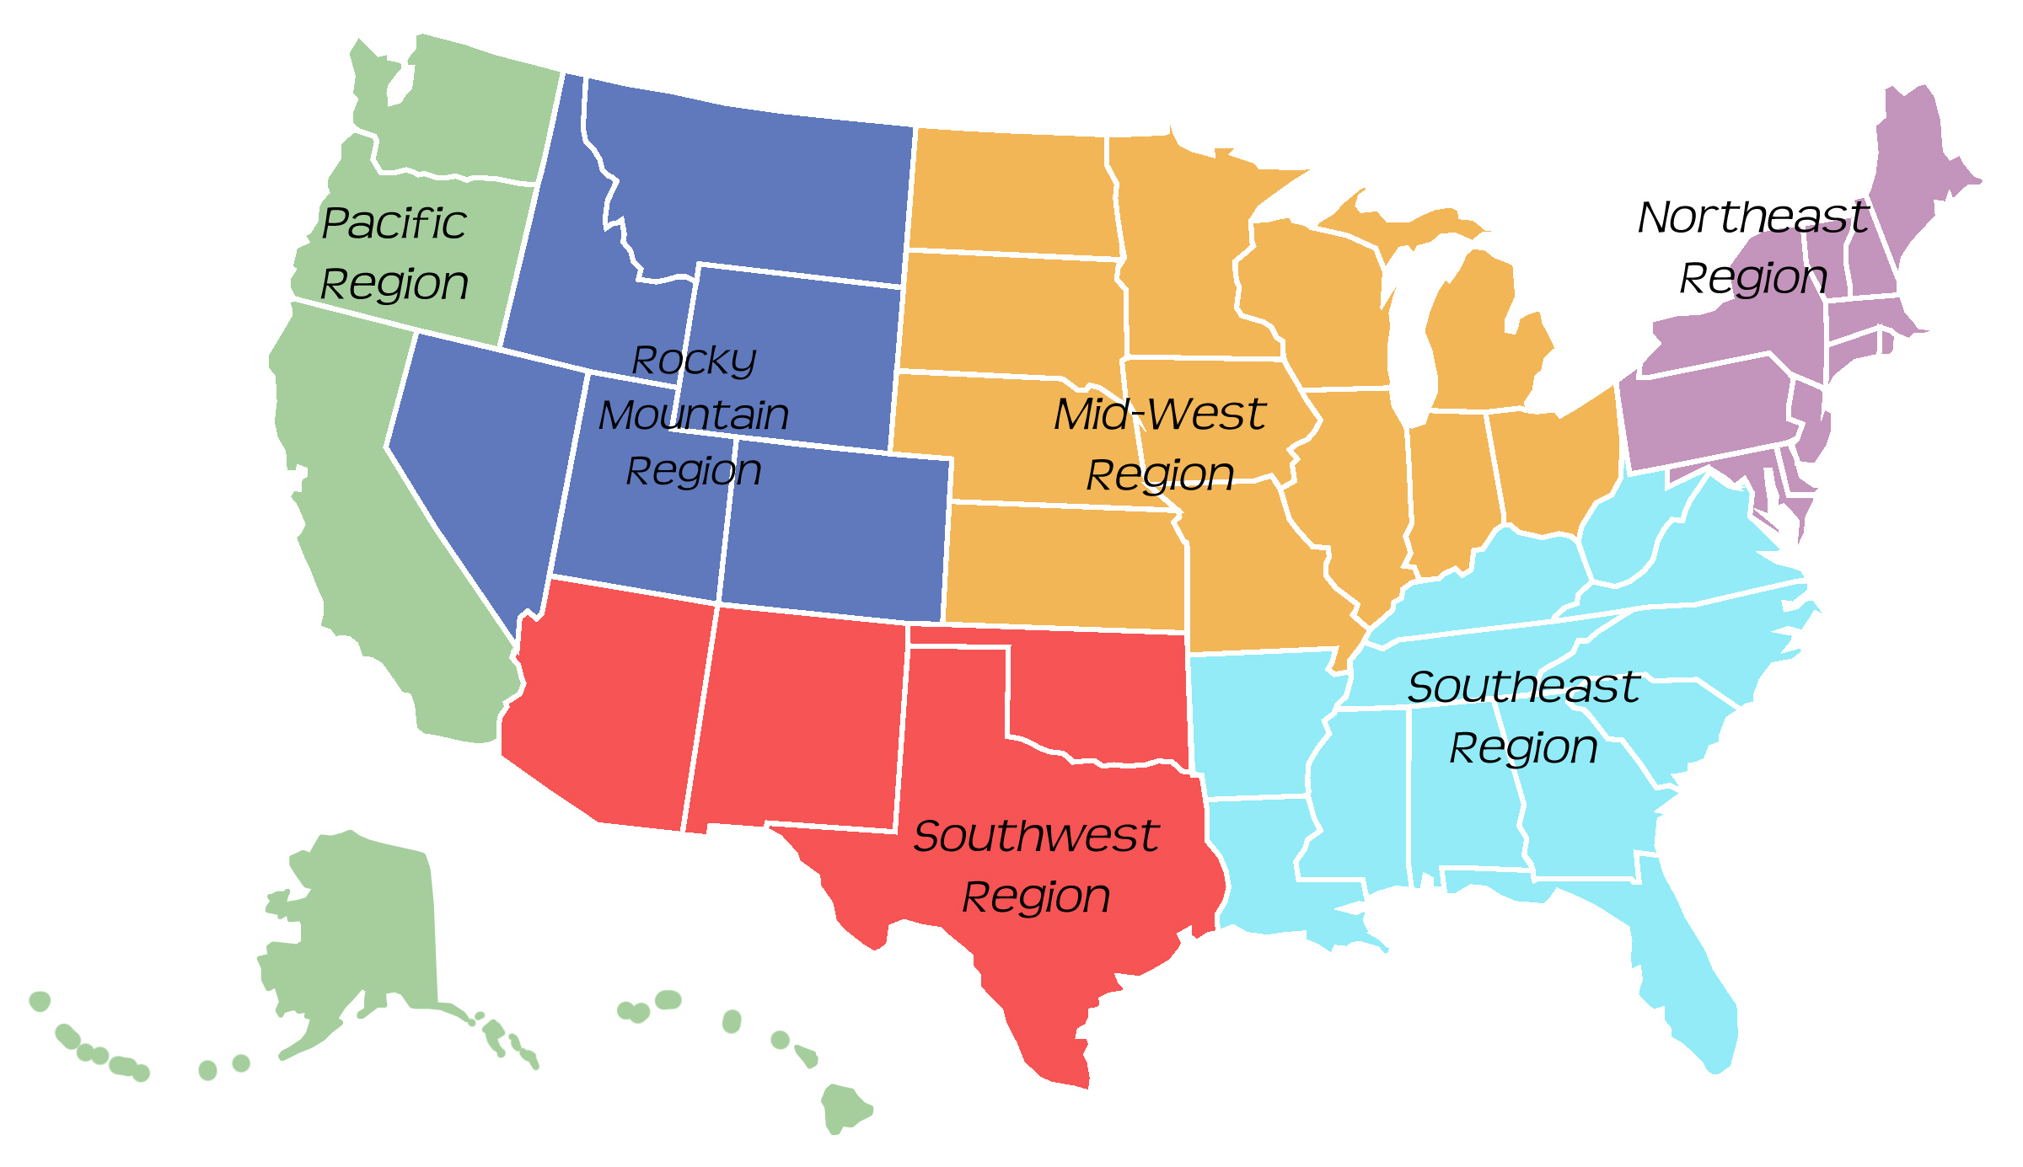

**USA Regions**

**Midwest**

* Illinois
* Indiana
* Iowa
* Kansas
* Michigan
* Minnesota
* Missouri
* Nebraska
* North Dakota
* Ohio
* South Dakota
* Wisconsin

**Mountain**

* Colorado
* Idaho
* Montana
* Nevada
* Utah
* Wyoming

**Northeast**

* Connecticut
* Delaware
* Maine
* Maryland
* Massachusetts
* New Hampshire
* New Jersey
* New York
* Pennsylvania
* Rhode Island
* Vermont

**South**

* Arizona
* New Mexico
* Oklahoma
* Texas

**Southeast**

* Alabama
* Arkansas
* Florida
* Georgia
* Kentucky
* Louisiana
* Mississippi
* North Carolina
* South Carolina
* Tennessee
* Virginia
* West Virginia

**West Coast**

* Alaska
* California
* Hawaii
* Oregon
* Washington